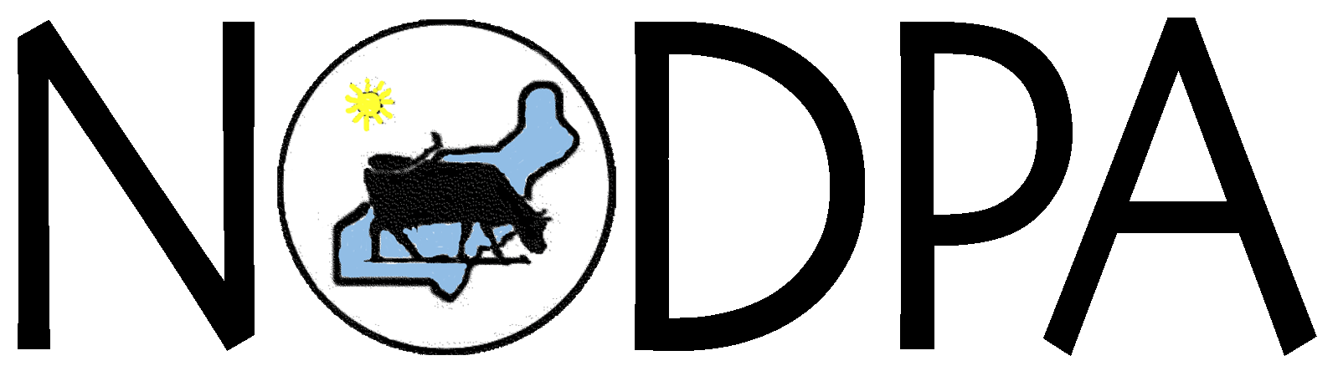
Northeast Organic Dairy Producers Alliance
Contact: Ed Maltby, NODPA Executive Director
Tel: (413)772-0444; Email: ednodpa@comcast.net

June may be Dairy Month but not for organic family farmers that sell to Horizon Organic who will see a pay cut of $1/cwt for their milk. NODPA urges consumers to buy more branded organic milk.

For Immediate Release: Deerfield, MA: The Northeast Organic Dairy Producers (NODPA) predicts a difficult summer and an impossible winter for organic dairy farmers. They announce their disappointment with Horizon Organic and condemn them for lowering their pay price because of “the low conventional price and the competition for the retail customer” and to “retain our customer base” and stay competitive in the marketplace. “Organic dairy farm families have seen their income shrink in 2008 with a pay price that did not increase enough to match the dramatic spike in their costs, by up to 50% in some cases,” says Executive Director Ed Maltby, “Organic dairy farmer’s costs have not dropped significantly in 2009 and now they are faced with another cut to their family income.”

Vermont organic dairy farmer Craig Russell found out about the drop in price at a local meeting with Horizon Organic officials. “Even with the best plans and tightest budgets, when the company that you sell your milk to decides to arbitrarily lower your annual income by $16,000, its difficult to know how we will survive,” says Craig, “We have been managing for the last year on a pay price that took little account of the increase in organic feed costs. I’ve "gotten more efficient" and "tightened my belt," I honestly don’t know what else to do.”

The cut in pay price will not have any effect on the retail price of organic milk and dairy products to consumers. Organic dairy farmers do not receive the same share of the retail dollar as their conventional colleagues. The higher prices that consumers pay for organic milk and dairy products should mean a sustainable pay price for farmers.

“Horizon Organic told their producers earlier this year, after two other major handlers cut their producer pay price, that they had no plans to lower theirs at that time. Now, all of a sudden they lower theirs too. Now, all of a sudden we feel the need to retract our earlier statement of support,” says Henry Perkins, Maine organic dairy farmer and NODPA President. “In my mind, there's no justification for lowering of the price paid to farmers as long as upper level management continues to receive high wages and bonuses. For far too long the farmer has had to bear the brunt of any and all economic downturns while management suffers not a whit, even though it was a management decision (to increase market share) that must share responsibility for any shortfall in profits.”

While the economic situation is creating hardship for everyone, organic dairy farmers are particularly vulnerable to the changes in the price they get paid for their milk. The majority of organic dairies are family owned operations that rely primarily on income from selling their milk wholesale. Since 2001, the average price paid to farmers for their organic milk has increased by only 29% while operational costs have increased by at least 50%.² This does not represent an adequate return for the skilled labor and capital investment of organic dairy producers or leave any money to maintain their property, or build a “rainy day fund.” Now Horizon Organic has joined HP Hood and Organic Valley in lowering the price they pay to farmers. This will affect the farm business bottom line and family income of those selling to Horizon by an average of $5,800 annually, or an average of a 15% wage cut. While most companies would be grateful for a 5-10% growth in this economy, organic dairy companies are taking the short term outlook and firing their farmers or cutting their annual wages by 10-15%.

“The lowering of my pay-price came as a surprise to me as I, and other farmers, were told only a few weeks ago by Horizon that there would be no lowering of price. I want a pay price that I can budget with and that my farm can thrive on,,” says New York organic dairy farmer George Wright, “ I encourage all consumers to purchase organic milk that is marketed by the brand name companies and ask our retail partners to work with us to sell as much organic milk as possible by using all available in-store promotions and specials.”

“We encourage consumers to support family farms and resist buying store brand milk which may come from questionable organic dairies,” says Pennsylvania organic dairy farmer and NODPA Treasurer, Dave Johnson, “While legitimate organic milk processors use private label milk to balance supply, factory farms skirting organic regulations can easily hide behind private labels which undercut brand names from family farm pasture based dairies.”

Despite what the milk companies are saying, operating costs for organic dairy farms have not yet dropped significantly in comparison with 2008 costs. Some have sought to intimidate organic family farmers by highlighting how low the conventional milk price is. Two wrongs do not make it right! “We see no value in comparing the exceptional low price paid to our conventional neighbors, except to point out that both are far below covering costs of production,” Henry Perkins added. While processors rushed to take on new farmers to supply their expanding market in good times, they failed to address supply management in the face of an economic downturn. Milk companies preferred to lower the price they pay farmers to save money and remain competitive. The message to farmers to reduce costs and accept a lower family income is causing enough uncertainty that the next generation of organic farmers is questioning the long-term viability of organic dairy.

“If consumers purchase organic milk with the USDA seal on it, they have a third party independent guarantee that it was produced without the use of antibiotics or artificial hormones and that the cows do not eat feed grown using chemical herbicides or pesticides. When you think of food safety, do not accept any false advertising hype - drink the real thing - organic milk with the USDA organic seal on it,” said NODPA Executive Director, Ed Maltby.
###
NODPA – website www.nodpa.com or www.organicmilk.org
The mission of the Northeast Organic Dairy Producers Alliance is to enable organic dairy family farmers, situated across an extensive area, to have informed discussion about matters critical to the well being of the organic dairy industry as a whole, with particular emphasis on:
- Establishing a fair and sustainable price for their product at the wholesale level.
- Promoting ethical, ecological and economically sustainable farming practices.
- Developing networks with producers and processors of other organic commodities to strengthen the infrastructure within the industry.
- Establishing open dialogue with organic dairy processors and retailers in order to better influence producer pay price and to contribute to marketing efforts.

Federation Of Organic Dairy Producers (FOOD Farmers)
The Federation Of Organic Dairy Producers is an umbrella group for the three regional organic dairy farmer organizations: Northeast Organic Dairy Producers Alliance (NODPA), Midwest Organic Dairy Producers Association (MODPA), and Western Organic Dairy Producers Alliance (WODPA). FOOD Farmers represents over 1,200 or two thirds of organic dairy farmers across the country.

¹ According toThe Nielsen Co., sales of organic food in the U.S. in December 2008 increased 5.6%, against a 25.6% rise during December 2007. 2 The data that has been collected by USDA Agricultural Research Service and the Universities of Vermont, Maine, and Wisconsin indicate that the base price paid to family farmers in the Northeast in 2007 should have been $28.50 and needs to rise to $33 for 2008 rather than the current average of $27.50.

